Capsim Final Value Estimate – Team Cedar

Erik Thompson
Octavia Pry
Capsim Round 7 – With expected Round 8 Score
Cumulative Profit at Round 7: $179,441,430
Cumulative Score at Round 7: 644
Expected Round 8 Score: 71.2
Expected Total for Round 8: 715.2

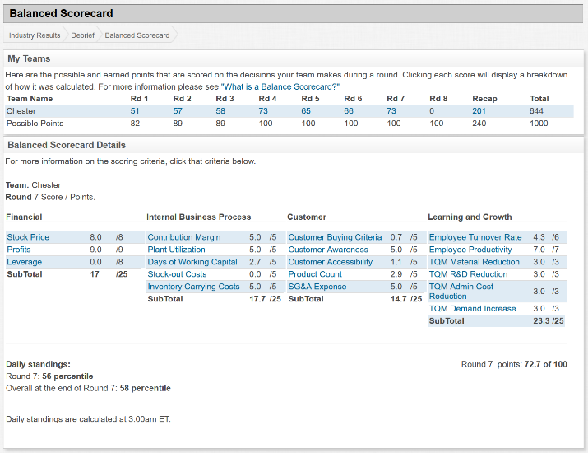 | 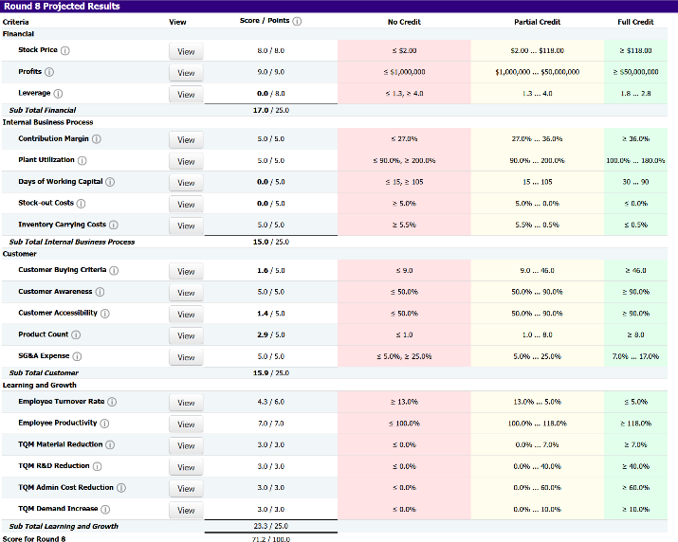
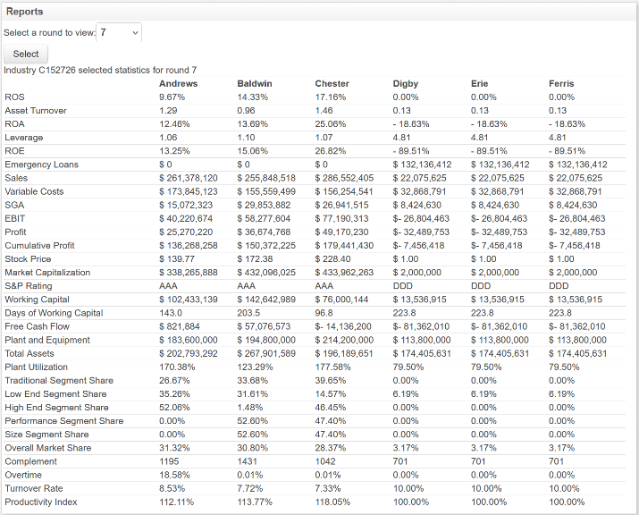 | 