Question 1
1.1 ER diagram (15 points)
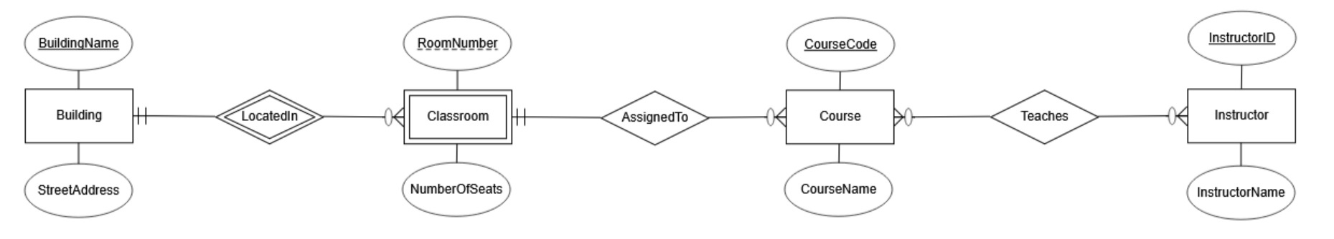
1.2 Mapping the ER diagram to a relational schema (10 points)
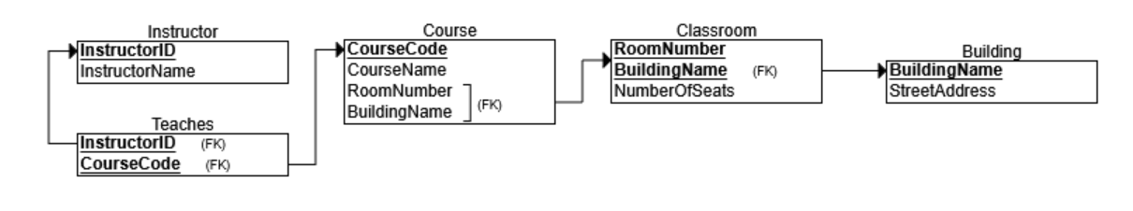
1.3 Based on your relational schemas from Question 1.2, write SQL statements to answer (10 points):
1. Calculate the total number of seats for each building
SELECT
BuildingName,
SUM(NumberOfSeats) AS TotalSeats
FROM
Classroom
GROUP BY
BuildingName;

2. Show the building address of the classroom for the course “Advanced Database”
SELECT
B.StreetAddress
FROM
Course C
JOIN
Classroom CL ON C.BuildingName = CL.BuildingName AND C.RoomNumber = CL.RoomNumber
JOIN
Building B ON CL.BuildingName = B.BuildingName
WHERE
C.CourseName = 'Advanced Database';

3. Show the names of instructors who teach “Advanced Database”
SELECT
I.InstructorName
FROM
Instructor I
JOIN
Teaches T ON I.InstructorID = T.InstructorID
JOIN
Course C ON T.CourseCode = C.CourseCode
WHERE
C.CourseName = 'Advanced Database';

