Question 3 Data Warehouse Modeling
- Based on the Orders Database and requirements listed above, create a dimensional model (star schema) for the data warehouse. Use ERDPlus to create the model (15 points)
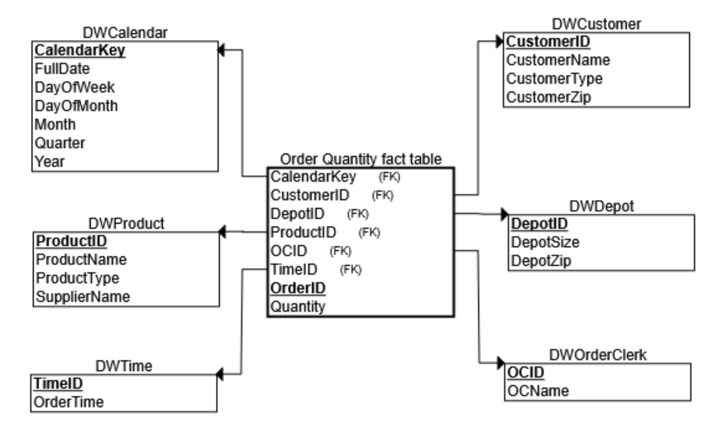
- Using sample data from the Orders Database, manually populate (no SQLs) the tables of the data warehouse created in a). (15 points)

DWCalendar
CalendarKey | FullDate | DayOfWeek | DayOfMonth | Month | Quarter | Year
1 | 1-Jan-2013 | Tuesday | 1 | January | Q1 | 2013
2 | 2-Jan-2013 | Wednesday | 2 | January | Q1 | 2013
3 | 3-Jan-2013 | Thursday | 3 | January | Q1 | 2013

DWTime
TimeID | OrderTime
1 | 9:00 AM

DWProduct
ProductID | ProductName | ProductType | SupplierName
P1 | BigGripper | Tire | Super Tires
P2 | TractionWiz | Tire | Super Tires
P3 | SureStart | Battery | Batteries Etc

DWCustomer
CustomerID | CustomerName | CustomerType | CustomerZip
C1 | Auto Doc | Repair Shop | 60137
C2 | Bo's Car Repair | Repair Shop | 60140
C3 | JJ Auto Parts | Retailer | 60605

DWDepot
DepotID | DepotSize | DepotZip
D1 | Small | 60611
D2 | Large | 60660
D3 | Large | 60611

DWOrderClerk
OCID | OCName
OC1 | Antonio
OC2 | Wesley
OC3 | Lilly

Order Quantity Fact Table
OrderID | CalendarKey | TimeID | ProductID | CustomerID | DepotID | OCID | Quantity
O1 | 1 | 1 | P1 | C1 | D1 | OC1 | 1
O1 | 1 | 1 | P2 | C1 | D1 | OC1 | 12
O2 | 2 | 1 | P2 | C2 | D1 | OC2 | 8
O3 | 2 | 1 | P2 | C3 | D2 | OC3 | 4
O3 | 2 | 1 | P3 | C3 | D2 | OC3 | 3
O4 | 3 | 1 | P3 | C2 | D2 | OC1 | 4
O5 | 3 | 1 | P2 | C2 | D3 | OC2 | 5
O6 | 3 | 1 | P1 | C3 | D3 | OC2 | 4

- Create a dimensional model (star schema) containing an aggregated fact table, where a fact table shows a summary of daily total quantity for each customer. Use ERDPlus to create the model. (10 points)
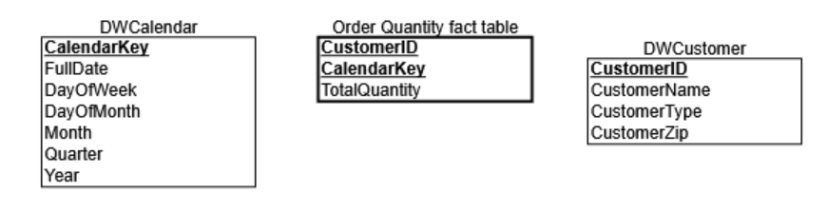
- Using the results from b), manually populate (no SQLs) this aggregated fact table. (10 points)
CalendarKey | CustomerID | TotalQuantity
1 | C1 | 13
2 | C2 | 8
2 | C3 | 7
3 | C2 | 9
3 | C3 | 4

