Question 1: Key: Value Pairs
1.1 Customer
Key | Value
1-2-333:Tina | 99202
2-3-444:Tony | 99223
3-4-555:Pam | 99004

1.2 Includes
Key | Value
6x6:T101:6% | 5
5x5:T101:3% | 2
1x1:T101:0% | 1
5x5:T102:5% | 3

Question 2: MapReduce Framework (30 points total, two parts)
2.1: University-rating pairs (Input Data)
File 1: (EWU, 9), (CWU, 7), (WWU, 9), (EWU, 6), (CWU, 8)
File 2: (EWU, 8), (WWU, 8), (CWU, 6), (WWU, 8), (CWU, 5)

Splitting
Node 1 (File 1): (EWU, 9), (CWU, 7), (WWU, 9), (EWU, 6), (CWU, 8)
Node 2 (File 2): (EWU, 8), (WWU, 8), (CWU, 6), (WWU, 8), (CWU, 5)

Mapping (Key-Value)
Node 1: (EWU, 9)
Node 2: (CWU, 7)
Node 3: (WWU, 9)
Node 4: (EWU, 6)
Node 5: (CWU, 8)
Node 6: (EWU, 8)
Node 7: (WWU, 8)
Node 8: (CWU, 6)
Node 9: (WWU, 8)
Node 10: (CWU, 5)

Shuffling (Group by University)
EWU: [9 (Node 1), 6 (Node 4), 8 (Node 6)]
CWU: [7 (Node 2), 8 (Node 5), 6 (Node 8), 5 (Node 10)]
WWU: [9 (Node 3), 8 (Node 7), 8 (Node 9)]

Reducing (Find Total)
EWU: sum(9, 6, 8) = 23
CWU: sum(7, 8, 6) = 26
WWU: sum(9, 8, 8) = 25

Final Output Table – University Rating
University Rating | Total
EWU | 23
CWU | 26
WWU | 25

2.2: Input Data (Product Quantity Pairs):
File 1: (BAG, 10), (BOOT, 10), (SOCK, 20)
File 2: (BAG, 10), (TENT, 10), (SOCK, 15)
File 3: (BAG, 20), (TENT, 10), (BOOT, 20)

Splitting
Node 1 (File 1): (BAG, 10), (BOOT, 10), (SOCK, 20)
Node 2 (File 2): (BAG, 10), (TENT, 10), (SOCK, 15)
Node 3 (File 3): (BAG, 20), (TENT, 10), (BOOT, 20)

Mapping (Key-Value)
Node 1: (BAG, 10)
Node 2: (BOOT, 10)
Node 3: (SOCK, 20)
Node 4: (BAG, 10)
Node 5: (TENT, 10)
Node 6: (SOCK, 15)
Node 7: (BAG, 20)
Node 8: (TENT, 10)
Node 9: (BOOT, 20)

Shuffling (Group by University)
BAG: [10 (Node 1), 10 (Node 4), 20 (Node 7)]
BOOT: [10 (Node 2), 20 (Node 9)]
SOCK: [20 (Node 3), 15 (Node 6)]
TENT: [10 (Node 5), 10 (Node 8)]

Reducing (Find Total)
BAG: sum(10, 10, 20) = 40
BOOT: sum(10, 30) = 30
SOCK: sum(20, 15) = 35
TENT: sum(10, 10) = 20

Final Output Table – Product Quantity
Product | Quantity
BAG | 40
BOOT | 30
SOCK | 35
TENT | 20

Question 3: Data Warehousing and ETL
- Relational Schema
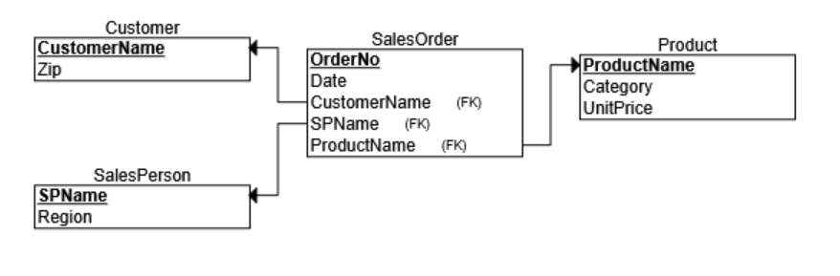
- Data Warehouse Star Schema Tables
DWProduct Dimension
PRODUCTKEY | PRODUCTNAME | PRODUCTPRICE | PRODUCTCATEGORY
1 | SafetyLite | 40 | Safety
2 | PowerGrip | 35 | Tools

DWCustomer Dimension
CUSTOMERKEY | CUSTOMERNAME | CUSTOMERZIP
1 | Summit Auto | 99004
2 | QuickFix | 99005

DWSalesperson Dimension
SPKEY | SPNAME | REGION
1 | Jamie | North
2 | Taylor | South

DWCalendar Dimension
DATEKEY | FULLDATE | DAYOFWEEK | MONTH | QUARTER | YEAR
1 | 06/01/2025 | Saturday | June | 2 | 2025
2 | 06/02/2025 | Sunday | June | 2 | 2025

DWStore - Fact Table
DATEKEY | CUSTOMERKEY | SPKEY | PRODUCTKEY | QUANTITY | AMOUNT
1 | 1 | 1 | 1 | 3 | 120
2 | 2 | 2 | 2 | 5 | 175

c) Star Schema
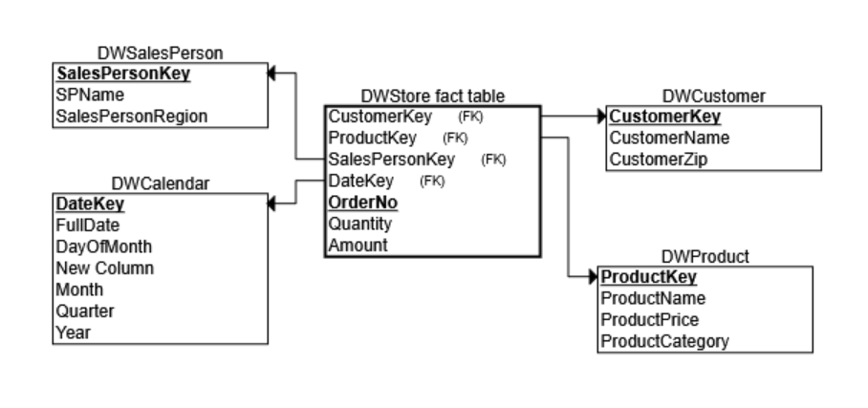

SQL Queries
(e) Populate the fact table

1.1 Populate DWProduct
INSERT INTO DWProduct (ProductName, ProductPrice, ProductCategory)
SELECT DISTINCT ProductName, UnitPrice, Category
FROM Product;

1.2 Populate DWCustomer
INSERT INTO DWCustomer (CustomerName, CustomerZip )
SELECT DISTINCT CustomerName, Zip
FROM Customer;

1.3 Populate DWSalesPerson
INSERT INTO DWSalesPerson (SPName, SalesPersonRegion )
SELECT DISTINCT SPName, Region
FROM SalesPerson;

1.4 Populate DWCalendar
SELECT DISTINCT Date AS FullDate, Format([Date], 'dddd') AS DayOfWeek, Day([Date]) AS DayOfMonth, Format([Date], 'mmmm') AS [Month], "Q" & Format([Date], 'q') AS Quarter, Year([Date]) AS [Year]
FROM SalesOrder;

1.5 Populate DWStore
Step 1 (PrepQ – DWStore):
SELECT OrderNo, Quantity, Amount
(SELECT SUM(Quantity *UnitPrice)
FROM SalesOrder, Product AS Amount
FROM SalesOrder, Product

Step 2 (Insert – DWStore):
INSERT INTO DWStore (OrderNo, Quantity, Amount)
SELECT OrderNo, Quantity, Amount
FROM [PrepQ - DWStore];

(f) Total Sales per Salesperson (DollarsSold – with Subqueries)
SELECT SPName,
(SELECT SUM(Quantity *Amount)
FROM DWStore, Product
WHERE DWStore.SalesPersonKey = SalesPerson.SalesPersonKey
AND DWStore.ProductKey = Product.ProductKey) AS DollarsSold
FROM DWSalesPerson
ORDER BY DollarsSold DESC;

(g) Aggregate Schema 